Deployment

🌟 Definition
# Source: AI Source: Provided by: [Data Path: Persons Table -> ID Column: 1, Name_En Column: Motasem Essam] -> From: [ChatGPT] on [6/7/2026]
Deployment is the sixth phase of the Software Development Life Cycle (SDLC) where the tested software is released and made available to users in a live (production) environment.
The main question in this phase is:
"How do we make the software available to users?"

🎯 Purpose of Deployment Phase
# Source: AI Source: Provided by: [Data Path: Persons Table -> ID Column: 1, Name_En Column: Motasem Essam] -> From: [ChatGPT] on [6/7/2026]
The goals of deployment are to:
- Release the software to users
- Move the application to the production environment
- Configure servers and databases
- Ensure the system operates correctly in real-world conditions
- Make the software accessible to end users

🔄 Deployment Process
# Source: AI Source: Provided by: [Data Path: Persons Table -> ID Column: 1, Name_En Column: Motasem Essam] -> From: [ChatGPT] on [6/7/2026]
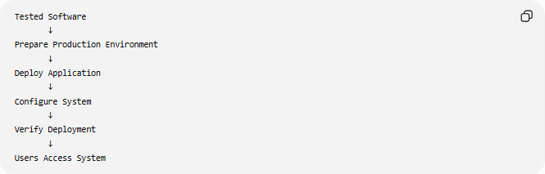
Tested Software
↓
Prepare Production Environment
↓
Deploy Application
↓
Configure System
↓
Verify Deployment
↓
Users Access System

🧩 Main Activities in Deployment

1️⃣ Prepare Production Environment
# Source: AI Source: Provided by: [Data Path: Persons Table -> ID Column: 1, Name_En Column: Motasem Essam] -> From: [ChatGPT] on [6/7/2026]
Definition
Set up the environment where the application will run.

Components
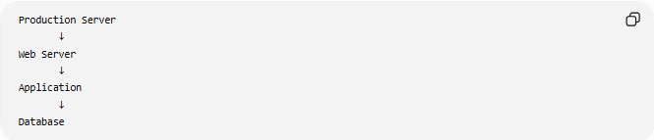
Production Server
↓
Web Server
↓
Application
↓
Database

Examples:
- Web servers
- Databases
- Cloud services
- Storage systems
- Security configurations

2️⃣ Install the Application
# Source: AI Source: Provided by: [Data Path: Persons Table -> ID Column: 1, Name_En Column: Motasem Essam] -> From: [ChatGPT] on [6/7/2026]
Definition
Move the application from the development/testing environment to production.

Example:
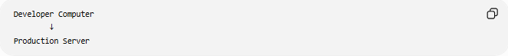
Developer Computer
↓
Production Server

Activities:
- Upload source code
- Install dependencies
- Configure environment variables

3️⃣ Database Deployment
# Source: AI Source: Provided by: [Data Path: Persons Table -> ID Column: 1, Name_En Column: Motasem Essam] -> From: [ChatGPT] on [6/7/2026]
Definition
Deploy database structures and data.

Example
Run migrations:
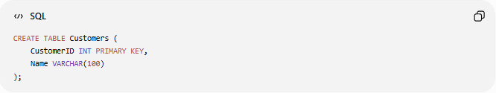
CREATE TABLE Customers (
CustomerID INT PRIMARY KEY,
Name VARCHAR(100)
);

Insert initial data:
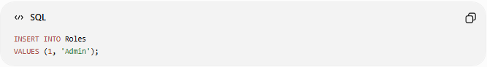
INSERT INTO Roles
VALUES (1, 'Admin');

4️⃣ Configuration
# Source: AI Source: Provided by: [Data Path: Persons Table -> ID Column: 1, Name_En Column: Motasem Essam] -> From: [ChatGPT] on [6/7/2026]
Definition
Configure system settings for production.

Examples:
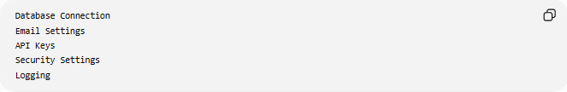
Database Connection
Email Settings
API Keys
Security Settings
Logging

Example:
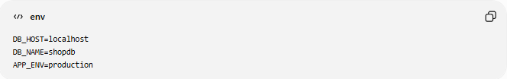
DB_HOST=localhost
DB_NAME=shopdb
APP_ENV=production

5️⃣ Deployment Verification
# Source: AI Source: Provided by: [Data Path: Persons Table -> ID Column: 1, Name_En Column: Motasem Essam] -> From: [ChatGPT] on [6/7/2026]
Definition
Confirm that the deployment was successful.

Checks include:
✅ Application starts correctly
✅ Database connection works
✅ APIs respond correctly
✅ Users can log in
✅ No critical errors

6️⃣ User Training (If Needed)
# Source: AI Source: Provided by: [Data Path: Persons Table -> ID Column: 1, Name_En Column: Motasem Essam] -> From: [ChatGPT] on [6/7/2026]
Definition
Teach users how to use the new system.

Examples:
- User manuals
- Documentation
- Training sessions
- Video tutorials

7️⃣ Go Live
# Source: AI Source: Provided by: [Data Path: Persons Table -> ID Column: 1, Name_En Column: Motasem Essam] -> From: [ChatGPT] on [6/7/2026]
Definition
The system becomes available to real users.

Example:
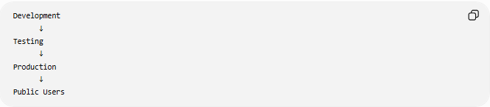
Development
↓
Testing
↓
Production
↓
Public Users

📚 Deployment Strategies

1️⃣ Direct Deployment (Big Bang)
# Source: AI Source: Provided by: [Data Path: Persons Table -> ID Column: 1, Name_En Column: Motasem Essam] -> From: [ChatGPT] on [6/7/2026]
Definition
Replace the old system with the new one immediately.

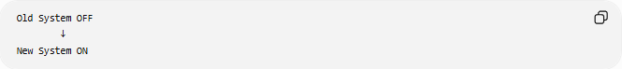
Old System OFF
↓
New System ON
Advantages
- Fast deployment
- Simple process
Disadvantages
- Higher risk
- Difficult rollback

2️⃣ Phased Deployment
# Source: AI Source: Provided by: [Data Path: Persons Table -> ID Column: 1, Name_En Column: Motasem Essam] -> From: [ChatGPT] on [6/7/2026]
Definition
Deploy the system gradually.

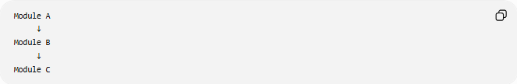
Module A
↓
Module B
↓
Module C
Advantages
- Lower risk
- Easier issue detection

3️⃣ Parallel Deployment
# Source: AI Source: Provided by: [Data Path: Persons Table -> ID Column: 1, Name_En Column: Motasem Essam] -> From: [ChatGPT] on [6/7/2026]
Definition
Run old and new systems simultaneously.

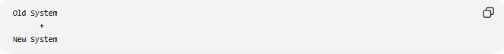
Old System
+
New System
Users compare results before switching fully.

Advantages
- Very safe
- Easy fallback
Disadvantages
- Higher cost

4️⃣ Blue-Green Deployment
# Source: AI Source: Provided by: [Data Path: Persons Table -> ID Column: 1, Name_En Column: Motasem Essam] -> From: [ChatGPT] on [6/7/2026]
Definition
Maintain two production environments.

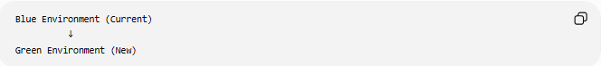
Blue Environment (Current)
↓
Green Environment (New)
Traffic switches when the new version is verified.

Advantages
- Minimal downtime
- Easy rollback

5️⃣ Rolling Deployment
# Source: AI Source: Provided by: [Data Path: Persons Table -> ID Column: 1, Name_En Column: Motasem Essam] -> From: [ChatGPT] on [6/7/2026]
Definition
Deploy updates gradually across servers.

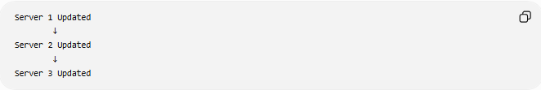
Server 1 Updated
↓
Server 2 Updated
↓
Server 3 Updated

🛠️ Tools Used in Deployment
# Source: AI Source: Provided by: [Data Path: Persons Table -> ID Column: 1, Name_En Column: Motasem Essam] -> From: [ChatGPT] on [6/7/2026]
Version Control
- Git

CI/CD Tools
- Jenkins
- GitHub Actions
- GitLab CI/CD

Containerization
- Docker
- Kubernetes

Cloud Platforms
- Amazon Web Services
- Microsoft
- Google

📄 Deployment Deliverables
# Source: AI Source: Provided by: [Data Path: Persons Table -> ID Column: 1, Name_En Column: Motasem Essam] -> From: [ChatGPT] on [6/7/2026]
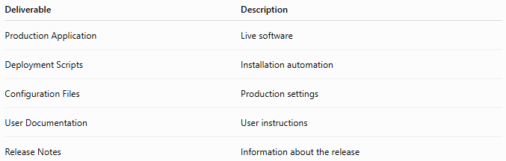
Deliverable | Description
Production Application | Live software
Deployment Scripts | Installation automation
Configuration Files | Production settings
User Documentation | User instructions
Release Notes | Information about the release

📊 Output of Deployment
# Source: AI Source: Provided by: [Data Path: Persons Table -> ID Column: 1, Name_En Column: Motasem Essam] -> From: [ChatGPT] on [6/7/2026]
At the end of deployment:
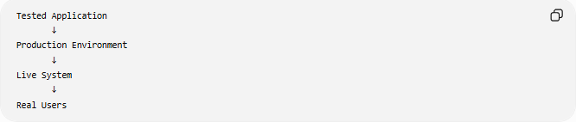
Tested Application
↓
Production Environment
↓
Live System
↓
Real Users

🌍 Real-World Example
# Source: AI Source: Provided by: [Data Path: Persons Table -> ID Column: 1, Name_En Column: Motasem Essam] -> From: [ChatGPT] on [6/7/2026]
Online Store Deployment
Deployment team:
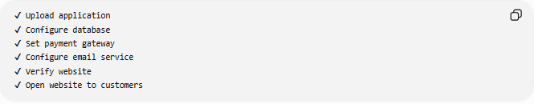
✔ Upload application
✔ Configure database
✔ Set payment gateway
✔ Configure email service
✔ Verify website
✔ Open website to customers
Customers can now use the store.

🧠 Simple Analogy
# Source: AI Source: Provided by: [Data Path: Persons Table -> ID Column: 1, Name_En Column: Motasem Essam] -> From: [ChatGPT] on [6/7/2026]
Building a house:
Deployment Phase
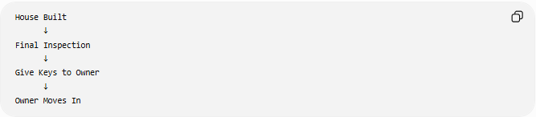
House Built
↓
Final Inspection
↓
Give Keys to Owner
↓
Owner Moves In
Software equivalent:
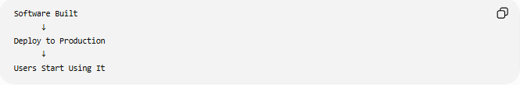
Software Built
↓
Deploy to Production
↓
Users Start Using It

🧭 Summary
# Source: AI Source: Provided by: [Data Path: Persons Table -> ID Column: 1, Name_En Column: Motasem Essam] -> From: [ChatGPT] on [6/7/2026]
The Deployment Phase is the SDLC stage where tested software is released to the production environment and made available to users. It includes preparing servers, deploying applications, configuring databases, verifying installation, and choosing an appropriate deployment strategy. The result is a live, operational system that users can access and use in real-world conditions.

